**Question 1. India: a growing success**

In 2016, the Indian economy grew by 7.5%. This made it the world’s fastest growing large

economy. In contrast, the Chinese economy grew by 6.8%. India had some other macroeconomic successes. Its price level rose by less in 2016 than it had in any year since 2004. The price of oil fell in 2016 and India is a large importer of oil. The government’s use of monetary policy helped to keep down rises in the general price level.

India’s manufacturing sector grew rapidly in 2016. One industry that performed particularly well

was the vehicle industry. India was the world’s sixth largest producer of vehicles, employing 26

million workers. India was the world’s largest producer of tractors. In 2015, the price of tractors

was increased. This led to a short-term fall in demand but a rise in revenue.

The growth of the vehicle industry has enabled firms in the industry to employ more specialised

workers and made it easier for these larger firms to borrow from banks. It is expected that the

industry will be able to recruit extra workers in the future because India’s labour force is growing.

In 2014, India’s labour force was 500m and this grew by 4% between 2014 and 2016.

The economic growth rate and the population growth rate in recent years are shown in Fig. 1.1.

The rate of economic growth and its stability affect households’ decisions on how much they spend and save.

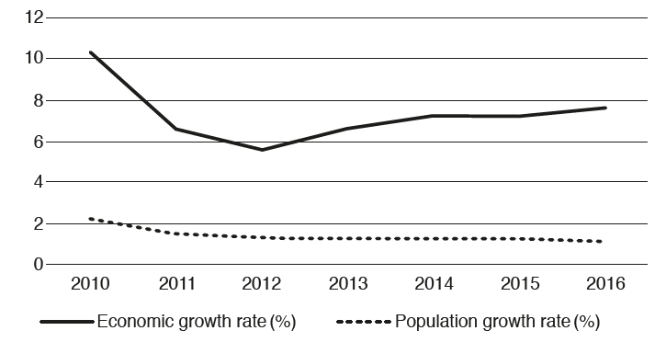

Fig. 1.1 India’s economic growth rate and population growth rate 2010–2016

The rising optimism about the performance of India’s economy has increased total demand in the economy. However, the Reserve Bank of India, the country’s central bank, has been relatively successful at keeping the inflation rate close to the government’s target which in 2016 was 4%. One influence on the country’s future macroeconomic performance will be changes in its population. India is set to have one of the world’s youngest populations by 2020, with an average age of only 29.

**(a)** Identify, using information from the extract, **two** reasons why India’s inflation rate fell in 2016. [2] A

**(b)** Explain, using information from the extract, whether demand for Indian tractors was

price-elastic or price-inelastic in 2015. [2] D

**(c)** Explain **two** internal economies of scale referred to in the extract. [4] A

**(d)** Calculate, using information from the extract, the percentage of India’s labour force that was employed in the vehicle industry in 2016. [2] D

**(e)** Analyse, using Fig. 1.1, what happened to India’s output and population over the period shown. [5] D

**(f)** Discuss whether or not a government should aim for a low rate of inflation. [5]D

**(g)** Explain, using information from the extract, **two** reasons why consumer expenditure may increase in India in the future. [4]A

**(h)** Discuss whether or not having a young population is a benefit to an economy. [6]D

**Question 2**

**Source 1**

**The economic problem results in people having to make choices. In Bulgaria, in recent years, people have changed how much they spend. The Bulgarian government is encouraging people to spend more. It is trying to ensure that deflation does not return and that the country will continue to experience an increase in output.**

**Source 2**

***Bulgaria’s economy shrank by 4.2% in 2020 rather than the expected 4.9% decline predicted by the European Commission, preliminary data from the National Statistical Institute found.***

Bulgaria’s economy in 2020 amounted to €60.6 billion, while the gross domestic product (GDP) per capita was at €8,748. This makes the country the EU’s poorest, lagging far behind Romania, which recorded a GDP per capita that was 25% higher.

Surprisingly, there was a 1.8% increase in consumption because Bulgaria has long supported the most liberal measures to deal with the pandemic in 2020

The European Commission expects the Bulgarian economy to grow by 2.7% this year and to fully rebound in 2022 with a 4.9% growth rate. The biggest problems are corruption and labour shortages due to a declining population.

The average wage in the EU’s poorest country continued to rise in 2020, reaching €750 before tax, compared to a €332 minimum wage, which is the lowest in the EU.

Most Bulgarian parties running in the upcoming parliamentary elections in April have made this figure the basic promised income of Bulgarians over the next four years.

While the ruling GERB party has promised to increase the average salary to €1,025 before taxation, most opposition parties have proposed the average salary to reach €1,250.

(Krassen Nikolov | EURACTIV.bg)

[Bulgarian economy performs better than expected – EURACTIV.com](https://www.euractiv.com/section/politics/short_news/bulgarian-economy-performs-better-than-expected/)

1. In a well laid out essay, **assess** the implications of falling output for country

**[18] A-6 C-6 D-6**

1. You are invited as one of the members of a panel of **guests on a TV Show to** **recommend** macroeconomic policies in countries undergoing low economic growth and deflation**. In your talk**:

* *Refer to the above sources.*
* *Make specific reference to the country of Bulgaria*
* *Use the Global context of Identities and relationships*
* *Use examples and terminology from your MYP studies*

*Remember to:*

* *Use persuasive language*
* *Organize your arguments and counter arguments (advantages and limitations of each chosen poicy)*

*The focus questions and description of the global context* *of* ***Identities and Relationship*** *are: Who am I? Who are we? Students will explore identity; beliefs and values; personal, physical, mental, social and spiritual health; human relationships including families, friends, communities and cultures; what it means to be human.*

**[30] A-10, B-10, C-10**